UNITED STATES ENVIRONMENTAL PROTECTION AGENCY
REGION 6
1201 ELM STREET, SUITE 500
DALLAS, TEXAS 75270

February 8, 2021

VH Techworks LLC
Attn: John Vega
12750 Perimeter Drive, Suite 102
Dallas, TX 75228

To Whom It May Concern:

This letter is to serve as notification that your Notification of Regulated Waste Activity Form (8700-12) has been received and processed. Your EPA ID number is:

TXR000009548

Future updates to your generator status, owner/operator information or other inquiries should be sent to your state environmental agency:

Texas Commission on Environmental Quality
Permitting and Registration Support Division
Registration and Reporting Section, MC129
P.O. Box 13087
Austin, TX 78711-3087
512-239-6413

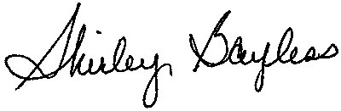
Sincerely,

Shirley Bayless
Management/Program Analyst
EPA, Region 6
Land, Chemical and Redevelopment Division

